**Experiment No.: 4**

**Aim**

To familiarize with set operations

1. List all the customers who are depositors but not borrowers.

SELECT CNAME FROM deposit WHERE CNAME NOT IN (SELECT CNAME FROM borrow);

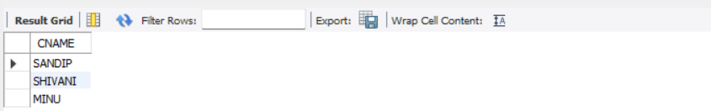

2. List all the customers who are both depositors and borrowers

SELECT CNAME FROM DEPOSIT UNION (SELECT CNAME FROM BORROW);

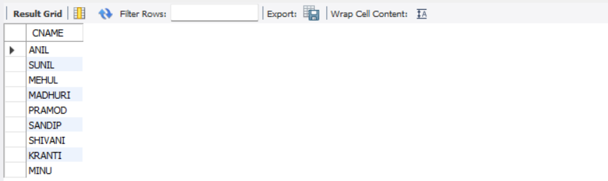

3. List all the depositors having deposit in all the branches where Sunil is having Account

SELECT D1.CNAME FROM DEPOSIT D1 WHERE D1.BNAME IN (SELECT D2.BNAME FROM DEPOSIT D2 WHERE D2.CNAME = 'SUNIL' );

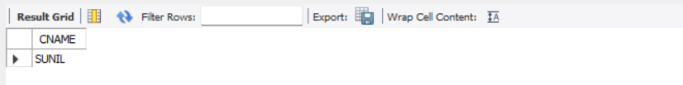

4. List all the customers living in city NAGPUR and having branch city BOMBAY or DELHI

SELECT C1.CNAME FROM CUSTOMER C1,DEPOSIT D1, BRANCH B1 WHERE C1.CITY = 'NAGPUR' AND C1.CNAME = D1.CNAME AND D1.BNAME = B1.BNAME AND B1.CITY IN ('BOMBAY','DELHI');

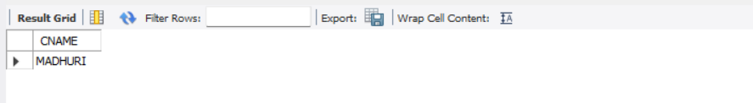

5. List all the depositors living in city NAGPUR

SELECT DISTINCT(CUSTOMER.CNAME) from CUSTOMER,DEPOSIT WHERE City='NAGPUR';

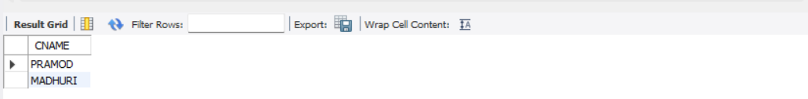

6. List all the depositors living in the city NAGPUR and having branch in city BOMBAY

SELECT C1.CNAME FROM CUSTOMER C1,DEPOSIT D1, BRANCH B1 WHERE C1.CITY = 'NAGPUR' AND C1.CNAME = D1.CNAME AND D1.BNAME = B1.BNAME AND B1.CITY IN ('BOMBAY');



7. List the branch cities of Anil and Sunil

SELECT B1.CITY FROM DEPOSIT D1, BRANCH B1 WHERE D1.BNAME = B1.BNAME AND D1.CNAME IN ('SUNIL' ,'ANIL');

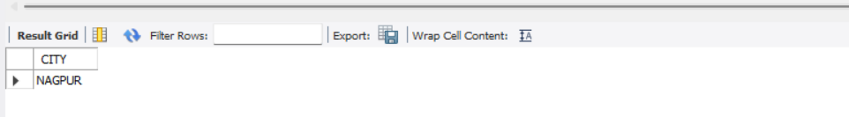

8. List the customers having deposit greater than 1000 and loan less than 10000.

SELECT DISTINCT D1.CNAME FROM deposit D1, borrow B1 WHERE D1.AMOUNT>1000 AND B1.AMOUNT<10000;

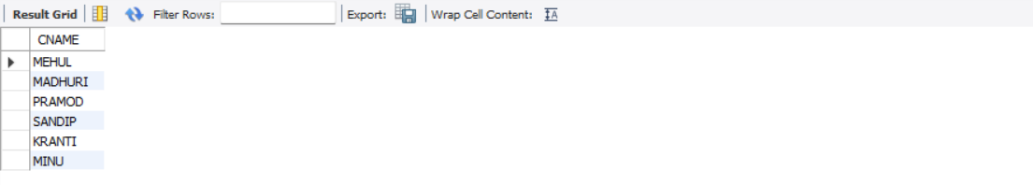

9. List the cities of depositors having branch VRCE.

SELECT B1.CITY FROM deposit D1, branch B1 WHERE D1.BNAME=B1.BNAME AND B1.BNAME='VRCE';

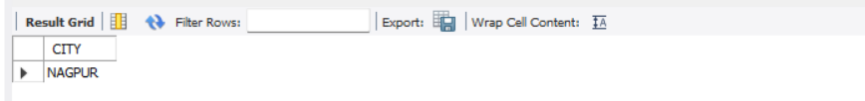

10. List the depositors having amount less than 1000 and living in the same city as Anil

SELECT D1.CNAME FROM deposit D1, customer C1 WHERE AMOUNT<1000 AND C1.CITY=(C1.CNAME='ANIL');

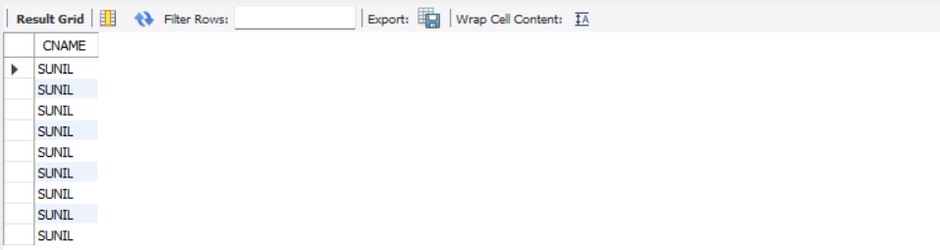

11. List all the cities where branches of Anil and Sunil are locate

SELECT B1.CITY FROM BRANCH B1 WHERE B1.BNAME IN (SELECT D1.BNAME FROM DEPOSIT D1 WHERE D1.CNAME IN ('ANIL','SUNIL'));



12. List the amount for the depositors living in the city where Anil is living

SELECT DISTINCT(D1.CNAME),D1.AMOUNT ,C1.CITY FROM deposit D1, CUSTOMER C1, BRANCH B1 WHERE D1.CNAME=C1.CNAME AND C1.CITY IN(SELECT C2.CITY FROM customer C2 WHERE C2.CNAME='ANIL');

